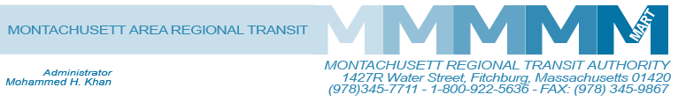

Posted 01/15/2015 at 8:34 am by JAV

MEETING OF THE MART ADVISORY BOARD
MART Maintenance Facility
1427R Water Street
Fitchburg, MA 01420

Tuesday, January 20, 2015
10:30 A.M.

Tentative Agenda

- Call to Order
- General Comments
- Financial Matters
A. Status of State Funding
B. Status of Federal Funding
C. Review Revenue and Expenditures 5 Months
D. Revised FY2015 Budget
Resolution- BE IT RESOLVED that the Advisory Board of the Montachusett Regional Transit Authority approves the revised FY2015 Budget as presented by its Administrator with a total local assessment not to exceed $2,006,825 in accordance with proposition 2 ½.
D. Status on Joining State Pension and GIC
Resolution – BE IT ROSOLVED that that the Advisory Board of the Montachusett Regional Transit Authority approves for MART to withdraw the petition for membership in the State Retirement System.

IV. Administrative Matters
A. Request for Additional Fixed Route Bus/Van Service in Lunenburg
B. Possible Commuter Bus/Van Service in Littleton, Boxborough and Devens to Coordinate with MBTA’s Commuter Rail Service
C. Status of Hiring for Controller Position
D. Proposed Fare Increase/Public Hearings
V. Capital Equipment/Facilities
- Improvement to the Commuter Rail Corridor between Fitchburg and Boston
- Wachusett Commuter Rail Extension Project – Station, Parking and Layover Facilities
C. Parking Improvement at Ayer-Rail Trail Facility-Transfer of designated property to MART from its owner
VI. Operational Services and Status Reports
A. MART Operation Status on Revenue and Ridership
1. Fitchburg/Leominster
2. Gardner and Mount Wachusett Community College
3. Athol MTG Services/Athol COA
VII. HST and Other Brokerage Status Reports

VIII. Other Business

IX. Adjournment
C: City and Town Clerks: Please post this notice pursuant to MA General Laws Chapter 30A,
Sections 18-25.

